Czech-Austrian Winter and Summer School

The People´s Republic of China energy agenda with special focus on nuclear power

Co-operating Universities



Financial support by

Prague and Vienna, 2010

Content
Content 2
1. Introduction 3
2. Energy demand and supply in China 4
Energy demand 4
Energy supply 7
3. China’s energy agenda regarding nuclear power 8
GHG and nuclear power 8
Building nuclear power plants 8
Safety Issues 12
Conclusions 14
References 14

1. Introduction
Our motivation to write this paper is to learn more about the Chinese energy market and its evolution, the demand and supply side, as well as its energy agenda. Special focus is set on China´s ambition to increase nuclear energy as part of its National Climate Change Programe (NCCP).
“Supply of energy is the crucial to our development,” Deng Xiaoping, former leader of the Communist Party of China, stressed in 1988. Ever since, China’s energy consumption has indeed been soaring. ... Between 2000 and 2006, China’s share in global energy consumption increased from 10 to 15 percent. The People’s Republic developed into the world’s second-largest energy consumer and is set to pass the United States as the number one between 2015 and 2020 (IP/A/CLIM/NT/2007-12, page 6). In order to have a better understanding about the countries energy system, we have to analyze the demand and supply side, as well as other factors that influence it.
China is a large country by surface, the most populated country in the world, with reported incredible economic growth for the past 20 years, but still, it is a developing country with low GDP per capita and with major regional disparities. PRC is ruled by the Communist Party of China (CPC) under a single-party system. The PRC exercises jurisdiction over 22 provinces, five autonomous regions, four directly administered municipalities (Beijing, Tianjin, Shanghai, and Chongqing), and two highly autonomous special administrative regions (SARs) - Hong Kong and Macau. From its founding in 1949 to late 1978, PRC was a Soviet-style centrally planned economy. Private businesses and capitalism did not exist. Leading the country towards a modern, industrialized communist society, China’s first president Mao Zedong instituted the Great Leap Forward. Following Mao's death and the end of the Cultural Revolution, Deng Xiaoping and the new Chinese leadership began to reform the economy and move to a market-oriented mixed economy under one-party rule, the CPC. China's economy is mainly characterized as a market economy based on private property ownership. In 2006, the current President Hu Jintao called for China to make the transition from a manufacturing-based economy to an innovation-based one and the National People's Congress has approved large increases in research funding. An innovation-based economy might be the answer to many problems the country is facing today.
China plans to use hydropower, nuclear energy, biomass fuels and gas to help cut 950 million metric tons of so-called greenhouse gas (GHG) output by 2010 as the country closes in on the U.S. as the biggest producer of harmful emissions (www.bloomberg.com). Under the National Climate Change Program, the first by a developing country, China pledges to restructure its economy, promoting clean technologies and improving energy efficiency (www.gov.cn). China is the world's second-largest power market, with more than 10 working reactors. But their total installed nuclear capacity only accounts for 2 percent of the country's total power generation, compared to 75 percent in France and 25 percent in Japan (www.cctc.com). The country is expected to build around 22 reactors in the five years ending 2010 and projected to build 132 units after and has the most aggressive nuclear power expansion program in the world (www.bloomberg.com).
All this different reports from public sources make us question our safety in the future, if China will be the leading nuclear power producer in the world. So far, they did not have the technology and know-how to build the reactors themselves, but this is progresively changing.

2. Energy demand and supply in China

Energy demand
Energy demand in China has largely evolved since the “Great Leap Forward” in 1958, compare figure 1: Energy Intensity of the Chinese Economy (1952-2006). In this period of time the CPC was in pursuit of Soviet-style industrialization, with directing the country´s economic resources out of agriculture into energy-intensive industries like steel and cement. Between 1949 and 1978, the amount of energy required to produce each unit of economic output tripled (figure 1).
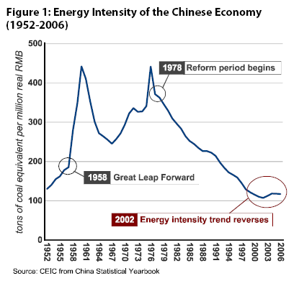

In the early 1980s the country was faced with famine as the agriculture sector failed to produce enough food for the entire population. The government started an innovative approach to help farmers by relaxing production targets, raising prices and increasing the autonomy of farming collectives. This eventually led farmers to new-found wealth of which they mainly invested into township and village enterprises (TVEs). TVEs became an engine of economic growth and especially this sector helped China to decrease their energy intensity by moving employment from energy-intensive industry into labor-intensive light manufacturing of garments, toys and shoes. The reform period also brought changes into the management of heavy industry with the introduction of economic incentives, like the right to keep profits, which improved their focus on expenses like energy. Energy management became also very important as a result of partial liberalization of oil, gas and coal prices. From the beginning of the reform period in 1978 till 2000, the chinese economic activity, due to all above stated reasons, required two thirds less energy per unit of output than in 1978, compare figure 1.
After the year 2000, the Chinese economy grew much faster than forecasted and with it grew its energy demand. The much greater surprise was the change in the energy intensity of economic growth and therefore a overall growth of energy consumption, which grew four times faster than predicted. „Under this scenario, China will account for 20 percent of global energy demand, more than Europe and Japan combined, and easily surpass the United States as the World´s larger energy consumer.“ (Rosen and Houser 2007, p. 7).
The recent evolution of China´s energy profile does not reflect the growth in consumption and transport, but the growth of energy-intensive heavy industry. There are reports that the industrial energy efficiency does continue to improve, as shown on figure 5, but fact is that a steel plant still uses substantially much more energy than a garment factory.
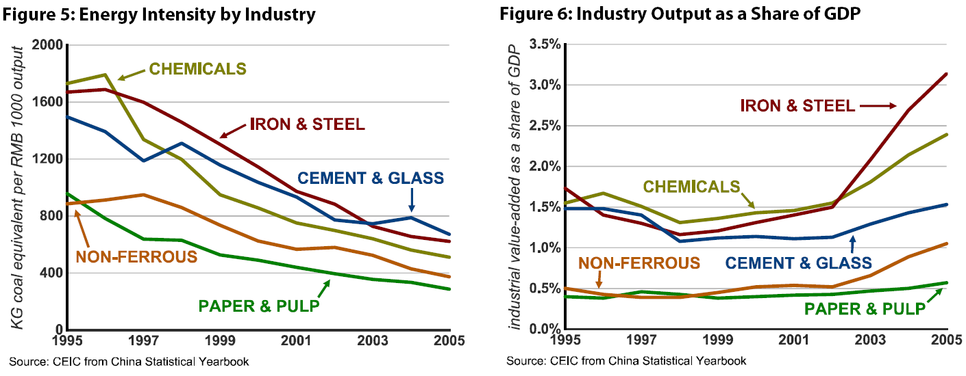
The structural shift that happened in the 1980´s, the shift towards light industry, has reversed and there is a clear trend in the rise of energy-intensive heavy industry, measured by output as a share of GDP (figure 6).
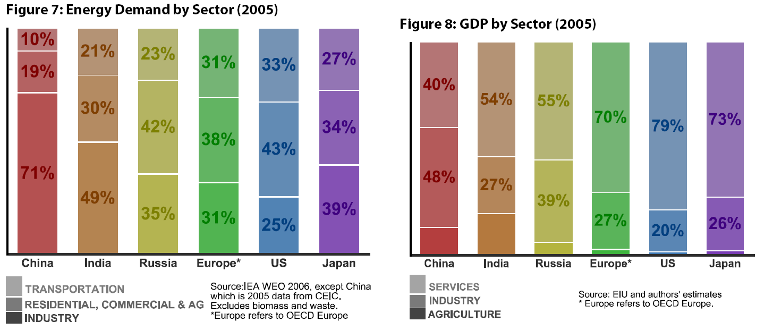
Today in China, the industry accounts for over 70 percent of final energy consumption, while the residential, commercial, agriculture and transportation sector account to less the 30 percent.
Energy demand in China is quite different from other developing and developed countries, compare figure 7. China is producing more of the energy intensive products like steel and aluminum, rather than relying on import from abroad. There are many reasons why more and more investments are being made into the energy-intensive sector, one is that provincial governments promote the heavy industry because it can earn them higher taxes, provide local availability of building goods and a higher contribution to their GDP. Rosen and Houser further found out that in 2006, profit margins in metals, glass, chemicals and cement industries exceeded those in textiles, apparel, furniture and electronics industries. All those stated advantages can also be proved in the number of companies that were set up in recent years in China, see table 1.
Table 1: Industry concentration (number of firms in China).
Industry | 2002* | 2004 | 2006
Iron & Steel | 3.551 | 4.947 | 6.959
Nonferrous Metals | 1.332 | 1.766 | 2.798
Cement Production | 4.656 | 5.042 | 5.210
Glass Products | 1.739 | 2.205 | 2.981
Paper & Pulp | 2.606 | 3.009 | 3.388
Chemical Materials | 12.481 | 15.172 | 20.083
Source: Beijing Kang Kai Information& Consultation from ISI Emerging Markets. 2002* number is from a February 2003 survey.
Figure 11 indicates that in 2005 China´s iron and steel industry consumed 16 percent of the country´s energy, compared with only 10 percent for all the households combined. Taken together, China’s heavy industry today consumes 54 percent of the country’s energy, up from 39 percent only five years ago (Rosen and Houser 2007, p. 14).
The residential energy demand is forecasted to be rising. Economists state that in some provinces the per capita GDP is over $5,000 USD and therefore the households are reaching income levels with which energy-intensive consumer goods like air conditioners and automobiles can be purchased. Rosen and Houser (2007) argue that the emerging middle class is more likely to work in an office than in a factory and, easily able to satisfy their food and shelter needs, have money left over to spend on consumer goods and services. If making the steel and glass to build office buildings and shopping malls is China’s current energy challenge, lighting heating and cooling those malls and offices is China’s future energy challenge. Today, the commercial sector accounts for less than 3 percent of total energy demand in the country. That share is set to expand as a function of rising incomes and a growing service sector.
Furthermore disturbing is the fact, that each year, over 10 million people are reclassified from rural to urban with most of them moving physically to new places and homes. (Demographic Yearbook 2006).

Energy supply
China´s energy supply is heavily dependent on coal and oil, see figure 16. Demand for coal, on which China relies for almost 70 percent of its energy needs has grown 12 percent annually since 2001. The overall picture shows a growing coal and oil demand, compare figure 17.
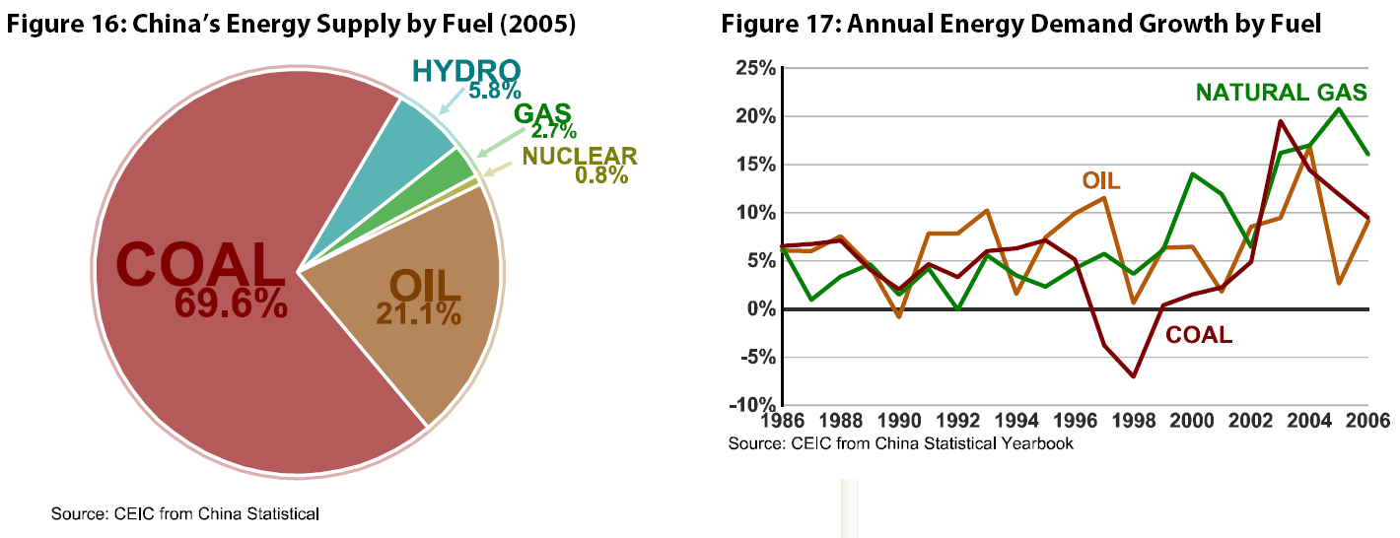
When we look at the overall picture of energy supply in China, we can find numerous reports about energy shortages, increasing fuel import dependence, price volatility and deteriorating environmental quality.
To date, energy sector reforms have lagged those in the rest of the economy. The coal, power, oil and gas industries remain torn between plan and the market. Competition has been introduced into some parts of the energy value chain (such as coal extraction and power generation) but state-owned monopolies/oligopolies remain dominant in others (power distribution and most of the oil and gas sectors). Upstream prices have mostly been liberalized, but downstream prices remain largely controlled. A small number of bureaucrats try to plan supply while markets are determining more and more of the demand. The result is a market structure and pricing system that favors supply expansion rather than demand management, and a regulatory framework that attempts to control that expansion through ham-fisted administrative measures rather than market-oriented price signals (Rosen and Houser 2007, p. 17).
Many economists argue that the existing policy system is inadequate for addressing China’s surging demand and its energy insecurity and environmental degradation that come with it.
The coal and power sector have the biggest impact on the country´s energy security, economic vitality and environmental sustainability. Alternative fuel sources, such as hydro, natural gas, wind and nuclear, have not yet had a great impact on the country´s energy security.
In China, the whole power generation is with 78 percent, heavily dominated by the coal-fired power technology. The reminder is mostly hydropower with 16 percent and nuclear, natural gas and renewables constituting less than 2 percent each, see figure 27. The dominance of coal fired power plants is taking its toll on the nation´s air and overall environmental quality. Less than 15 percent of these coal power plants have flu gas desulphurization (FGD) systems (used to remove SO2 from emission streams) installed and even fewer have them running.

3. China’s energy agenda regarding nuclear power

GHG and nuclear power
Energy production and transformation is identified as one of the key areas for GHG mitigation. Therefore, part of the plan of China's national climate change programme is to actively promote the development of nuclear power:
Nuclear power should be regarded as an important component of national energy strategy, hence the proportion of nuclear power in China’s national primary energy supply will increase gradually, and construction of nuclear power stations in the coastal regions with faster economic development and heavy electricity load should be expedited; unify technology approach and adopt advanced technology to realize independent and domestic construction of large-scale nuclear power stations and improve the overall capacity of nuclear power industry by the principle of self-dependence, international cooperation, technology transfer and promoting independence. Through the countermeasures mentioned above, it is expected that the GHG emissions can be reduced by about 50 Mt CO2 by 2010 (China's National Climate Change Programme 2007).

Building nuclear power plants
In this part you will find information about Chinese policy in the field of constructions Nuclear power plant. We discuss problems and challenges that China faces. There are some problems that must be solved by the companies that produce nuclear parts. One is they must secure quick construction on many new plants and still care about world atom security. They must cooperate with international organization and other states of the world. Our goal is to resolve and see the challenges that we face in China. In Czech republic we want to build another block in Nuclear power plant and there is question if we can secure supplies of nuclear components. We want to know how big will be demand in this sector from China. So the goal is to see possibilities to cooperate and earn money with China in the new world that we will be live in.

In the paragraph below you cen see growing trends of nuclear energy in last twenty year in China.
In the next map you can see actual situation in Nuclear reactors in China.

In 2009 Chinese nuclear plants produced about 1.9 percent of total energy supply. They operated 11 nuclear reactors that produced 8587 MWh. Others 23 reactors were in construction and they will produce 25.310 MWh. Other 34 reactors are planned in time of June 2010 with producing capacity 38.160 MWh. It is important to add that another 120 reactors are proposed, so China has scheduled space for construction next plants. To complete our big picture we have to say, that actual running plants need 2.875 tons of uraniun per year. In comparison the Czech Republic needs 678 tons, Austria needs nothing of it for nuclear plant and Slovenia 145 tons (world-nuclear.org).
Additional reactors are planned, including some of the world's most advanced, to give a sixfold increase in nuclear capacity to at least 60 GWe or possibly more by 2020, and then a further substantial increase to 200 GWe by 2030.
China is rapidly becoming self-sufficient in reactor design and construction, as well as other aspects of the fuel cycle. The economic loss due to pollution by coal plants is put by the World Bank at almost 6% of GDP. Because of the heavy reliance on old coal-fired plant, electricity generation accounts for much of the country's air pollution, which is a strong reason to increase nuclear share (world-nuclear.org).
In 2009 power shortages were most acute in central provinces, particularly Hubei, and in December the Central China Grid Co. posted a peak load of 94,6 GW. At the end of 2009, China had budgeted to spend $600 billion upgrading its grid (mostly by the firm The State Grid Corporation). At present time China has enormous logistic problems – nearly half the country's rail capacity is used for transporting coal. Nuclear power has an important role, especially in the coastal areas, remote from the coalfields and where the economy is developing rapidly. Generally, nuclear plants can be built close to centers of demand, whereas suitable wind and hydro sites are remote from demand. Moves to build nuclear power commenced in 1970 and the industry has now moved to a rapid development phase. Technology has been drawn from France, Canada and Russia, with local development based largely on the French element. The latest technology acquisition has been from the USA (via Westinghouse, owned by Japan's Toshiba) and France. The Westinghouse AP1000 is the main basis of technology development in the immediate future (world-nuclear.org).
The paragraph below shows the current number of Chinese nuclear power plants under construction.
Name | Maximum  capacity | Current phase capacity | Construction started | Active  capacity | Reactor types | Sheduled completition
Ningde | 6.000 MW | 2.000 MW | Feb. 18, 2008 | 0 MW | 2XCPR-1000 | 2012
Hongyanhe | 6.000 MW | 4.000 MW | Aug. 18, 2007 | 0 MW | 4XCPR-1000 | 2014
Yangjiang | 6.000 MW | 2.000 MW | Sept. 26, 2007 | 0 MW | 2XCPR-1000
Ling'ao | 4.000 MW | 2,000 MW | May 1997 | 2,000 MW | 2 × PWR 938/990,  2 × CPR-1000 | 2011/2012
Qinshan | 4.340 MW | 1,300 MW | 1984 | 3,040 MW | PWR, PHWR
Fangjiashan | 2.000 MW | 2,000 MW | April 2008 | 0 MW | CPR-1000 | 2013/2014
Fuqing | 6.000 MW | 2,000 MW | Oct. 2007 | 0 MW | CPR-1000 | 2013/2014
Sanmen | 6.000 MW | 2,000 MW | Feb. 26, 2008 | 0 MW | 2 × AP1000 | 2013/2014
Haiyang | 8.700 MW | 2,000 MW | July 29, 2008 | 0 MW | 2 × AP1000 | 2015
Taishan | 6.000 MW | 3,400 MW | Aug. 26, 2008 | 0 MW | 2 × EPR | 2013
Xianning | 10.000 MW | 2,000 MW | Aug. 12, 2008 | 0 MW | N/A | 2015
Total | 65.040 MW | 24.700 MW |  | 5.040 MW
Source: Wikipedia.com (2010)

Nuclear power plants have long construction lead times (even in China, since the usual corners cannot be cut in nuclear) and still involve lengthy negotiations with foreign firms (Rosen and Houser 2007, p. 27).

Safety Issues
China organize some meeting around Nuclear safety. Like On 29, June 2008 the 2nd ASEAN+3 Nuclear Safety Forum hosted by the Ministry of Environment Protection. There was signed Southeast Asia Nuclear Weapon-free Zone Treaty by the Thailand, China and other ASEAN states (enews.emcot.net).
Very interesting is the history of China National Nuclear Corporation (CNNC). The CNNC is the successor to the Ministry of Nuclear Industry which built China's first atom bomb, hydrogen bomb and nuclear submarine. It functioned as a government bureau for the national nuclear industry and reported directly to the State Council. It oversaw China's nuclear-related corporations, manufacturers, institutions, research institutes, and plants, including those related to nuclear weapons. It was responsible for the design and operation of nuclear power plants; nuclear fuel production and supply, including the processing of natural uranium, uranium conversion and enrichment, fuel assembly fabrication, spent fuel reprocessing, and nuclear waste disposal. (globalsecurity.org) So we can expect that they have experience with security.
The second big nuclear company is China Guangdong Nuclear Power Group (CGNPG). CGNPG's first nuclear station uses reactors designed and built by the French National Company, Framatome. Then it developed an improved PWR (Pressurized Water Reactor) called CPR1000 based on the French type. CPR1000 is a fully Chinese designed and constructed reactor type which takes a large proportion in all the reactors being built in China, and is believed to be the company's main presentation of its innovation power.
In February 2007 CGNPG signed a contract with Areva to build Taishan nuclear station with Areva's European Pressurized Reactor, On the other hand Xianning nuclear station will use Westinghouse Electric Company's AP1000. These two events make this company among the first ones to build a nuclear station with generation 3+ reactors (neimagazine.com).
By the technology China will use we can say that there should be enough security control systems because it will be produced mostly by the western companies with many experiences in the sector. The other question is how good will be personnel and directions from the state. As we know directive that receive engineers in Chernobyl lead to the catastrophe. But more specific evaluation of future behavior is hard to recognize from the accesible information.
Nuclear energy is an integral part of China's energy strategy and will increasingly contribute to China's total energy supply. China has more than twenty civilian facilities, including power reactors, mines, and enrichment plants, to support its nuclear power program. As China operates more nuclear plants, more nuclear materials will be produced and stockpiled, and more nuclear facilities will be spread around the country. To ensure that this expanded network of nuclear facilities does not increase the risk that nuclear materials will be diverted or become the target of attack, China will need to develop more reliable domestic nuclear security strategies. China is also poised to become a major exporter of nuclear energy technology. China has committed to keeping nuclear technologies out of the hands of dangerous states and/or sub-state organizations as well as sharing nuclear technologies, but in order to meet its nonproliferation obligations, Chinese policy makers will need to strengthen nuclear export controls and practices.
The nuclear security has the impact even at the international relationship. For example by the Washington post China wanted to punish USA for selling guns to Taiwan by not visiting nuclear security congress of 40 world state. But on the other hand, China has the excessive interest in presentation of its nuclear security interest. (Washington Post)
Yet inside and outside the country, the speed of the construction program has raised safety concerns. China has asked for international help in training a force of nuclear inspectors. The last country to carry out such a rapid nuclear expansion was the United States in the 1970s, in a binge of reactor construction that ended with the Three Mile Island accident in Pennsylvania in 1979. And China is placing many of its nuclear plants near large cities, potentially exposing tens of millions of people to radiation in the event of an accident.
“At the current stage, if we are not fully aware of the sector’s over-rapid expansions, it will threaten construction quality and operation safety of nuclear power plants,” Li Ganjie, the director of China’s National Nuclear Safety Administration, said in a speech.
In August, the Chinese government dismissed and detained the powerful president of the China National Nuclear Corporation, Kang Rixin, in a $260 million corruption case involving allegations of bid-rigging in nuclear power plant construction, according to official media reports. No charges have been reported against Mr. Kang, who is being held incommunicado for interrogation.
While none of Mr. Kang’s decisions publicly documented would have created hazardous conditions at nuclear plants, the case is a worrisome sign that nuclear executives in China may not always put safety first in their decision-making. The arrest of Mr. Kang, a member of the Chinese Communist Party’s powerful Central Committee, can be seen as evidence of China’s seriousness about safety.
In contrast with its performance in industries like toys, China has a strong safety record in industries like aviation, which receive top-level government attention.
The challenge for the government and for nuclear companies as they increse construction is to keep an eye on a growing army of contractors and subcontractors who may be tempted to cut corners.
“It’s a concern, and that’s why we’re all working together because we hear about these things going on in other industries,” said William P. Poirier, a vice president for Westinghouse Electric, which is building four nuclear reactors in China.
Philippe Jamet, the director of the division of nuclear installation safety at the International Atomic Energy Agency in Vienna, said that China had welcomed foreign inspectors at its reactors and that “they show pretty good operations safety.” But he added that the international agency was concerned about whether China would have enough nuclear inspectors with adequate training to handle the rapid expansion.
“They don’t have very much staff, when you compare their staff with how many they will need,” Mr. Jamet said. The agency accepted a Chinese request to send a team of international experts to the country next year to assess staffing and training, he added.
China has two rival state-owned nuclear power giants: the China National Nuclear Corporation, mainly in northeastern China, and the China Guangdong Nuclear Power Group, mainly in southeastern China.
Western experts regard the Daya Bay nuclear power plant in Shenzhen, which mainly uses French designs and is run by China Guangdong Nuclear, as evidence that China can run reactors safely. A display case holds trophies the power plant won in global safety competitions (nytimes.com).

Conclusions
Energy demand in China is growing so rapidly that even if the industry manages to meet the ambitious 2020 target, nuclear stations will still generate only 9.7 percent of the country’s power, by the government’s projections.
The speed of the construction program has raised safety concerns, inside and outside the country. To show its commitment to world energy security, China has asked for international help in training of nuclear inspectors. Chinas engineers learned how to make and design their own technology, which makes nuclear technology by all possible means cheaper and more accesible for indigent states. We could become a supllier of two big national Companies - CNNC and CGNPG.
The challenge for China is and will be - to build and operate its nuclear reactors without the equivalent of the Three Mile Island accident, in which a reactor core partly melted and released radioactivity, or the Chernobyl disaster in the former Soviet Union in 1986, the world’s worst civilian nuclear accident.

References
- Biggest deal, http://www.neimagazine.com/story.asp?storyCode=2050696 (10.6.2010)
- China National Nuclear Corporation, http://www.globalsecurity.org/wmd/world/china/cnnc.htm (10.6.2010)
- China to Cut Greenhouse Emissions by 950 Million Tons, http://www.bloomberg.com/apps/news?pid=20601103&sid=aM8H5XjNVbFQ (08.02.2010)
- China aims to build its own nuclear power stations, http://www.cctv.com/program/bizchina/20090724/101260.shtml (08.02.2010)
- China to Build More Nuclear Plants, http://www.bloomberg.com/apps/news?pid=20601101&sid=a2lUkzmYNGWI (08.02.2010)
- China's energy policy in the light of climate change, and options for cooperation with the EU, http://www.europarl.europa.eu/activities/committees/studies/download.do?file=18035 (08.02.2010)
- China's National Climate Change Programme, June 2007. www.ccchina.gov.cn/WebSite/CCChina/UpFile/File188.pdf (08.02.2010)
- Four Pillars of Support for Fast-Globalizing Nuclear Industry, http://www.world-nuclear.org/uploadedFiles/WNA_Brochure_%284_Pillars%29.pdf (18.04.2010)
- Nuclear Power in China, http://en.wikipedia.org/wiki/Nuclear_power_in_China (7.6.2010)
- Rosen, D. and Houser T. China energy. A guide for the perplexed. http://www.iie.com/publications/papers/rosen0507.pdf (18.04.2010)
- The China Sustainable Energy Programe, http://www.efchina.org/FHome.do (08.02.2010)
- The Security Implications of China's Nuclear Energy Expansion, http://belfercenter.ksg.harvard.edu/publication/20110/security_implications_of_chinas_nuclear_energy_expansion.html (7.6.2010)
- United Nations, Demographic yearbook 2006, 58. Issue, United Nations Economic and Social Affairs, New York: 2008.
- World Nuclear Symposium, http://www.wna-symposium.org/ (18.04.2010)
- World Nuclear News http://www.world-nuclear-news.org/ (18.04.2010)
- http://www.cgnpc.com.cn/n2881959/n3075227/n3075274/n3075437/3670495.html (5.6.2010)
- http://belfercenter.ksg.harvard.edu/publication/20110/security_implications_of_chinas_nuclear_energy_expansion.html (5.6.2010)
- http://www.washingtonpost.com/wp-dyn/content/article/2010/03/28/AR2010032801419.html (5.6.2010)
- http://www.nytimes.com/2009/12/16/business/global/16chinanuke.html?_r=2&partner=rss&emc=rss&pagewanted=all (5.6.2010)
- http://en.wikipedia.org/wiki/China_Guangdong_Nuclear_Power_Group (7.6.2010)
- http://www.eia.doe.gov/cabs/China/Electricity.html
- ASEAN+3 nuclear safety forum kicks off in Bangkok, june 2008
- http://enews.mcot.net/view.php?id=4782&t=1 (10.6.2010)

